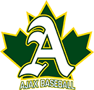
AJAX Spartans Baseball

Player Release Policy

Players that wish to play Rep baseball and are Ajax
residents, are required to attend AMBA tryouts
in the appropriate age group.

If a position is not offered to the player upon
completion of all tryouts for their age group,
they may request a release from the
Rep Convenor.

Updated July 25, 2022

