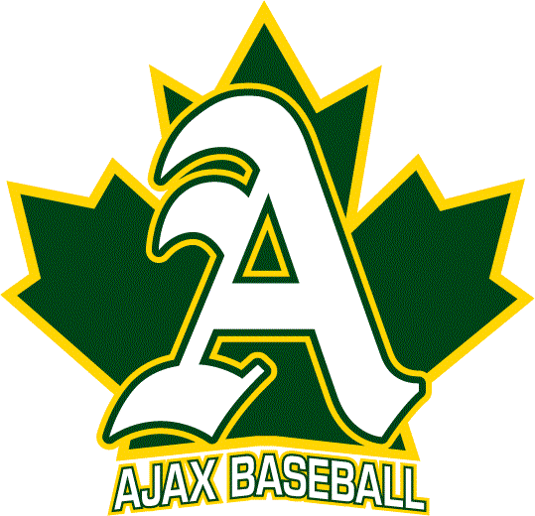 | 2021 REP MANAGER /  HEAD COACHING  APPLICATION

Contact Info
First Name: |  |  |  | Last Name
Address:
Phone (Home): |  |  |  | Mobile:
Email: |  |  | NCCP (coaching card) # CC:

Preferred Coaching Assignment
 | Minor Rookie Tier 1 | 2013 |  | Peewee Tier 2 | 2008
 | Rookie Tier 2 | 2012 |  | Bantam Tier 2 | 2006
 | Mosquito Tier 2 | 2010 |  | Midget T2 | 2003-04
 | Minor Peewee Tier 2 | 2009

Coaching Certification / Training Experience
Have you participated in the National Coaching Certification Program? |  |  |  |  | Yes | No
If yes, please indicate your current certification: |  |  | Level I |  | Yes | No
 |  |  | Level II |  | Yes | No
 |  |  | Level III |  | Yes | No
Coaching Experience
Year | Sport / Association | Age / Division |  | Position
Briefly respond to the following:

Outline your coaching philosophy

Provide a brief summary of how you would select players

Provide a brief summary of how you would select your coaches

Outline your first practice (2 hour slot)

Outline your player development plan for the season

Add any additional information you feel will aid in evaluating your application

References (please provide at least three references)
Name | Telephone No | e-Mail Address

Please submit by email to | John.warwick@cibc.com
Deadline for Applications is | August 24th
Interviews will begin | Week of August 17th
Team Managers (Head Coaches) will be announced: | Week of August 31st
Tryouts Begin | Week of September 14th

